The Air Ambulance Service

STRATEGIC PLAN
2015-2020

“Rising to the Challenges of Emergency Healthcare”

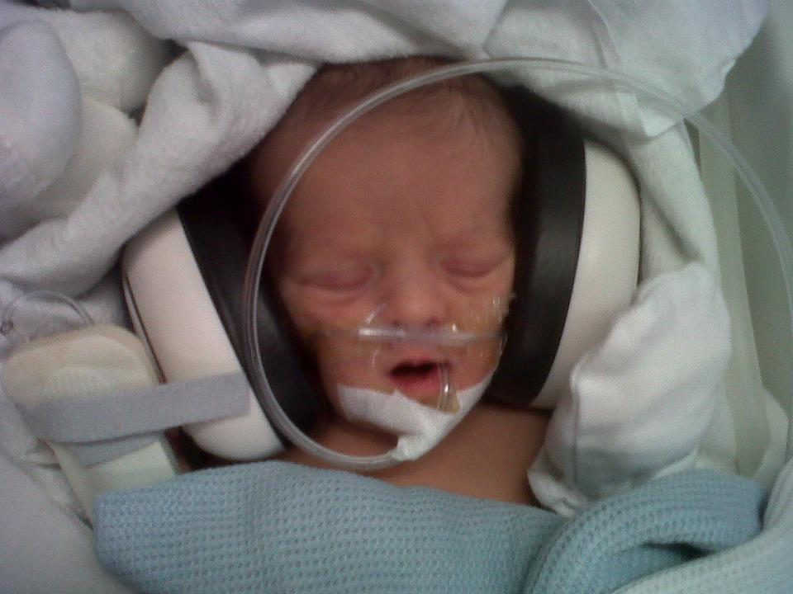

STRICTLY PRIVATE & CONFIDENTIAL
FOR INTERNAL COMMUNICATION ONLY

Pride and Purpose
As an organisation we are clear on three things, our ultimate aim (The Vision), the impact we make on Society (The Mission) and the way we go about achieving this important work (The Values). Every individual in every part of our charity needs to hold these three things dear to them, for we are not here to do an ordinary job; we are here for a purpose driven by passion, commitment and humanity.
We are about people not machines, our purpose is to make a difference to those needing Emergency Health Care, which in turn will make a real difference to communities and to society as a whole. Our responsibility is far reaching. The obvious impact is on saving lives, improving clinical outcomes and being able to react quickly and efficiently to emergencies, but our influence is also able to create and be able to innovate in clinical care, we have the courage to challenge the boundaries that often exist in State-run services and we have the ability to invest heavily in the development of the people who deliver that care. We will meet and exceed standards set by The Care Quality Commission and the Civil Aviation Authority and be at the forefront of sustaining the highest standards across our industry. We do all this because we care. We care deeply about people.
Our primary purpose is healthcare and we will lead the way in our field, but our reach goes much further in our impact on society.
We are a significant employer and contributor to our local economies. Recognition of this aspect of our work by Business and both National and Local Government will stand us in good stead to play a significant role in our wider surroundings. By the end of this strategic plan, we will have created hundreds of sustainable jobs and we will be spending millions to contribute very positively to our economies and in doing so we will have saved many lives and improved many others.
Our business and income-generating activities are ethical, professional and meet National standards set by The Fundraising Standards Board, The Institute of Fundraising and The Institute of Directors. Using the EFQM or Business Excellence Model as a Framework for quality management, we will always ensure a culture of continuous improvement, strong work ethic and genuine aspiration.
We are a socially responsible organisation that values the very communities that support us. We must therefore make our expertise available to smaller charities, to education establishments and to organisations with similar goals. We must show that we care about our environment and we must use our abilities to change, shape or challenge the voluntary sector as a whole for genuine public benefit.
This is an organisation that engenders pride and purpose in every individual associated with it. So as we set out on this new and exciting pathway, let it truly become an organisation of real courage, real creativity and most of all real compassion.
Andy Williamson – Chief Executive
About Us
The Air Ambulance Service
We are an emergency healthcare charity.
Our Vision
We want children to grow into adults and adults to live longer, making bereavement through trauma rare.

Our Mission Statement

Our rapid response services work tirelessly to save lives and alleviate pain and suffering, wherever and whenever needed.

Our Core Values
The core values that will drive the organisation are: Compassion, Courage and Creativity.

Compassion
We succeed because we care. We care about our patients, our supporters, our partners and our colleagues. We act with dignity, humility and respect.

Courage
We succeed because we dare. We are bold and pioneering. We are brave enough to ask questions of ourselves and others and to take action.

Creativity
We succeed because we innovate. We recognise that new ideas, big and small, are essential for our future. We are curious and embrace change.

Those three core values will be at the heart of everything we do and will drive our people to achievement, no matter how large or small, in all areas of our work.

The Strategic Plan 2015 – 2020

Having established our vision, mission and values we now turn our attention to how we are going to achieve this (The Strategy), what we are going to do (The Tactics) and who will do it and when (The Business Plan).

We have six key strategic aims to develop over the next five years and these are to:
- Continuously advance rapid response critical care services to patients.
- Be recognised as a leading authority on pre-hospital emergency care and paediatric transfer services.
- Raise awareness, understanding and engagement with our charity across the country.
- Unite people in the common purpose of our charity.
- Be the organisation of choice and opportunity for the most talented and driven from diverse backgrounds.
- Grow income to £20 million in a diverse and sustainable manner to continue and develop our services.

The delivery of the overall strategy is an organisational responsibility. Whilst each and every department and individual will have ownership of their very specific areas and tasks, we also share the same ethos, same vision and most importantly we share the same goal. Collaboration, communication and co-operation across all disciplines and departments will lead to a more effective output and ultimately a more comprehensive result.

Therefore we now outline the key tactics and implementation plans for each area of the business in order that objectives are clearly defined and staff are aware of where and how to input into the plan.



Strategic aim 1 Continuously advance rapid response critical care services to patients.

Key Tactics:
- Extend our services to a 24 hour, 7 days a week model
- Assess need and then provide out of hours RRVs to supplement HEMS services.
- Provide 95% doctor cover.
- Define the clinical skills set and competencies of a critical care paramedic and achieve the required competence.
- Upgrade TCAA from AW109 to AW169 by end 2016.
- Assess need for a second helicopter and location of both aircraft.
- Liaise with NHS partners to determine needs for additional services.

Strategic aim 2 Be recognised as a leading authority on pre-hospital emergency care and paediatric transfer services.

Key Tactics:
- Map who the key influencers are in Government, the NHS and the Media and build meaningful relationships.
- Provide evidence-based reporting and comment on pre-hospital emergency care and paediatric transfer services.
- Develop calls to action and policy positions.
- Train and support clinical staff in public affairs and media.

Strategic aim 3 Raise awareness, understanding and engagement with our charity across the country.

Key Tactics:
- Develop appreciation and understanding across all parts of the Organisation of the importance of having a strong brand.
- Develop brand structure and charity brand story.
- Map our supporter/potential supporter audiences.
- Map our NHS partners.
- Develop an annual communication plan for above audiences.
- Train and support staff in public affairs and media.
- Empower people to act as ambassadors for the Charity.

Strategic aim 4 Unite people in the common purpose of our charity.

Key Tactics:
- Develop an internal communication strategy.
- Create staff representative group
- Create volunteer representative group
- Develop more opportunities for face-to-face communication
- Celebrate successes
- Utilise key individuals and story-telling
- Engage external suppliers, partners, supporters and other stakeholders to greater involvement.

Strategic aim 5. Be the organisation of choice and opportunity for the most talented and driven from diverse backgrounds

Key Tactics:
- Establish the Charity as a learning organisation
- Invest in leadership development
- Develop a leading reward and recognition programme
- Reaffirm our culture of freedom to act alongside a willingness to take ownership and responsibility.
- Ensure our everyday behaviours are aligned with our core values of compassion, courage and creativity.
- Invest in infrastructure to facilitate the achievement of our long-term aims.

Strategic aim 6. Grow income to £20 million in a diverse and sustainable manner to continue and develop our services.

Key Tactics:
- Build core regular income.
- Develop new and innovative methods of income generation.
- Increase applications to all Grant Giving bodies including Trusts and Foundations, lottery and corporate funds as well as engage with their Trustees for support and awareness.
- Increase promotion of legacy giving through marketing and engagement with the legal profession and community involvement.
- Accelerate the development of high level donors and ambassadors.
- Develop major corporate partnerships for TCAA.
- Maximise potential fundraising in HEMS operating areas.
- Develop integrated marketing campaigns.
- Drive financial efficiencies.

Underneath all of these key tactics is a business plan detailing how we will approach meeting the strategic objectives. This is a separate internal document.

